DOCUMENTATION
Abstract:
The Guessing the Word Game is a simple interactive console-based application designed to improve logical thinking, vocabulary, and basic programming skills. In this game, the system randomly selects a word from a predefined list, and the player attempts to guess the word by entering letters within a limited number of attempts. The program provides feedback for correct and incorrect guesses and may also offer hints to assist the player. This project demonstrates the effective use of arrays, strings, conditional statements, loops, and random number generation in programming, making it suitable for beginners learning problem-solving through coding.

Introduction:
Games play an important role in enhancing learning by making it interactive and engaging. The Guessing the Word Game is a classic example of a word-based game where the player identifies a hidden word by guessing letters step by step. Each correct guess reveals the position of the letter in the word, while incorrect guesses reduce the remaining attempts.

This project is developed to understand fundamental programming concepts such as array manipulation, string handling, control structures, and user input/output operations. The game logic is simple, yet it effectively illustrates how programming constructs work together to build a functional application. Due to its simplicity and clarity, the Guessing the Word Game is commonly used as an academic mini-project in introductory programming courses.

Software Requirements:
• Operating System:
Windows / Linux / macOS
• Programming Language:
C / Python (depending on implementation)
• Compiler / Interpreter:
• GCC (for C language)
• Python 3.x Interpreter (for Python)
• Development Environment (Optional):
• Code::Blocks
• Visual Studio Code
• PyCharm
• Libraries / Modules:
• Standard libraries (stdio.h, string.h, stdlib.h, time.h in C)
• Built-in modules (random in Python)

Hardware Requirements:
• Processor:
Intel or AMD processor (minimum 1 GHz)
• RAM:
Minimum 2 GB (4 GB recommended)
• Storage:
At least 100 MB free disk space
• Input Devices:
Keyboard
• Output Devices:
Monitor / Display Screen
CODE:
#include <stdio.h>
#include <stdlib.h>
#include <string.h>
#include <time.h>

#define MAX_ATTEMPTS 6
#define WORD_COUNT 6
#define WORD_LENGTH 20

// Words and hints
char words[WORD_COUNT][WORD_LENGTH] = {
"python",
"github",
"computer",
"keyboard",
"internet",
"program"
};

char hints[WORD_COUNT][50] = {
"A popular programming language",
"Platform for hosting code",
"An electronic device",
"Used to type",
"Connects the world",
"Set of instructions"
};

void playGame() {
srand(time(NULL));
int index = rand() % WORD_COUNT;

char word[WORD_LENGTH];
strcpy(word, words[index]);
char hint[50];
strcpy(hint, hints[index]);

int guessed[26] = {0};
int attempts = MAX_ATTEMPTS;
int correct = 0;

printf("\n🎯 GUESS THE WORD GAME 🎯\n");
printf("You have %d attempts.\n", MAX_ATTEMPTS);

while (attempts > 0) {
correct = 1;
printf("\nWord: ");

for (int i = 0; i < strlen(word); i++) {
if (guessed[word[i] - 'a']) {
printf("%c ", word[i]);
} else {
printf("_ ");
correct = 0;
}
}

if (correct) {
printf("\n🎉 YOU WON! The word is: %s\n", word);
return;
}

printf("\nAttempts left: %d", attempts);
if (attempts == 3) {
printf("\n💡 Hint: %s", hint);
}

printf("\nEnter a letter: ");
char ch;
scanf(" %c", &ch);

if (ch < 'a' || ch > 'z') {
printf("❌ Enter lowercase letters only.");
continue;
}

if (guessed[ch - 'a']) {
printf("⚠️ Already guessed.");
continue;
}

guessed[ch - 'a'] = 1;

if (!strchr(word, ch)) {
attempts--;
printf("❌ Wrong guess!");
} else {
printf("✅ Correct!");
}
}

printf("\n💀 GAME OVER! The word was: %s\n", word);
}

int main() {
char choice;

do {
playGame();
printf("\nPlay again? (y/n): ");
scanf(" %c", &choice);
} while (choice == 'y' || choice == 'Y');

printf("\nThanks for playing! 👋\n");
return 0;
}

RESULT:
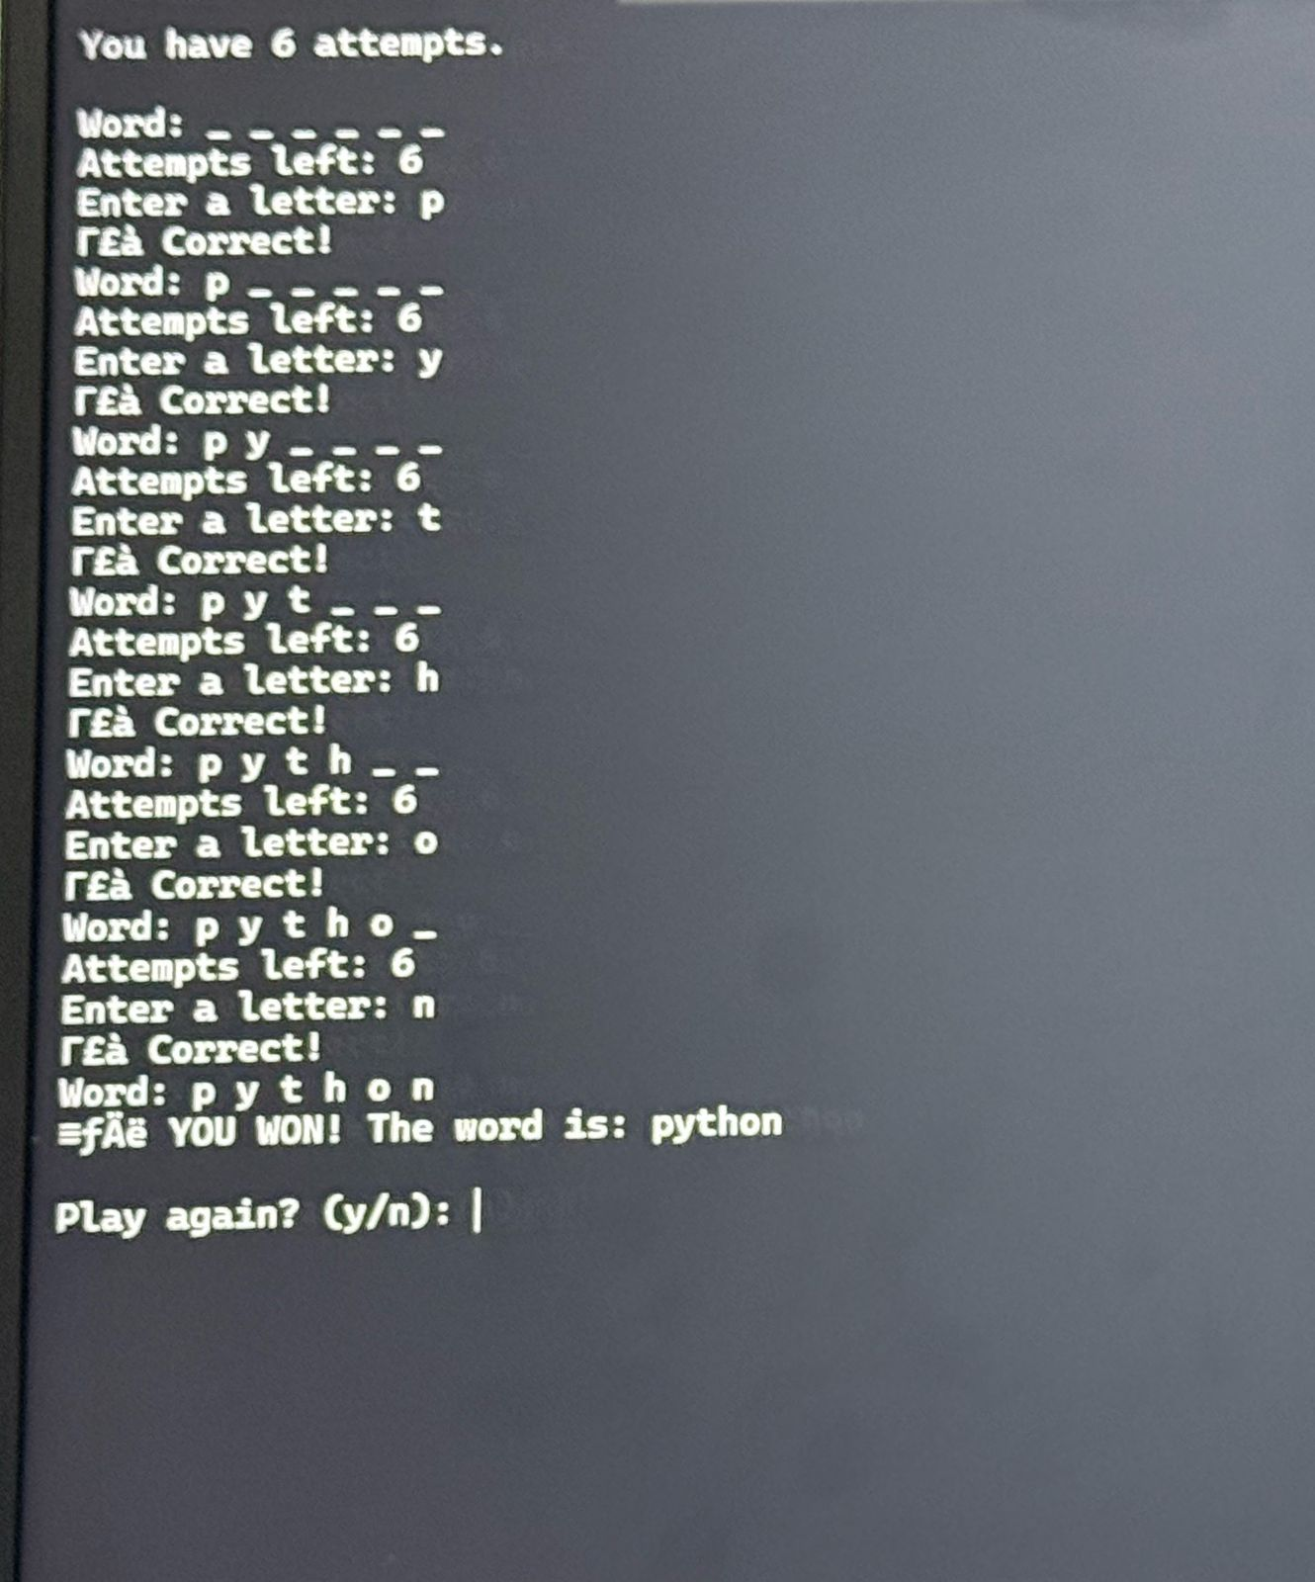

CONCLUSION:
The Word Guessing Game is a simple yet effective program that demonstrates the practical application of fundamental C programming concepts. Through this game, users interact with the system by guessing letters to identify a hidden word within a limited number of attempts. The program enhances logical thinking, problem-solving ability, and understanding of program flow. It also provides hands-on experience with handling strings, user input, and decision-making in C. Overall, this project serves as a good learning tool for beginners and helps in strengthening core programming skills through an interactive and engaging approach.

